***PROGRAMMING FUNDAMENTALS***

***LAB:4***

***Name : Ali Naqi Class & Section :BCS-1K***

***Date : 10 September 2025 Roll No. :25k-0920***

**Task 4:**

#include<stdio.h>

int main(){

int P;

printf("Enter Your Percentage:");

scanf("%d",&P);

if(P>=90){

printf("Your Grade is A");

}

else if(P>=80 && P<90){

printf("Your Grade is B");

}

else if(P>=70 && P<80){

printf("Your Grade is C");

}

else if(P>=60 && P<70){

printf("Your Grade is D");

}

else if(P<60){

printf("Your Grade is F");

}

else{

printf("Invalid Percentage");

}

}

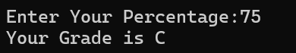

**Task 5:**

#include<stdio.h>

int main(){

int num;

printf("Enter a Number(1-3):");

scanf("%d",&num);

switch(num){

case 1:

printf("Stop");

break;

case 2:

printf("Ready");

break;

case 3:

printf("Go");

break;

default:

printf("Please Enter Number(1-3)");

}

return 0;

}



**Task 6:**

#include<stdio.h>

int main(){

int num1,num2;

char op;

printf("Enter Number 1:");

scanf("%d",&num1);

printf("Enter Number 2:");

scanf("%d",&num2);

printf("Enter a Operator(+,-,*,/):\n");

scanf(" %c",&op);

switch(op){

case '+' :

printf("Sum of Number 1 and Number 2 is:%d ",num1+num2);

break;

case '-':

printf("Differnce between Number 1 and Number 2 is:%d ",num1-num2);

break;

case '*' :

printf("Multiplication of Number 1 and Number 2 is: %d",num1*num2);

break;

case '/' :

printf("Division of Number 1 and Number 2 is: %d",num1/num2);

break;

default:

printf("Please Enter Correct Operator");

}

return 0;

}

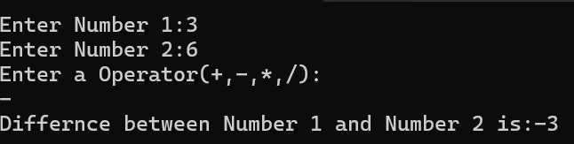

**Task 7:**

#include <stdio.h>

int main() {

int year;

printf("Enter a year: ");

scanf("%d", &year);

if ((year % 400 == 0) || ((year % 4 == 0) && (year % 100 != 0))) {

printf("%d is a Leap Year.\n", year);

} else {

printf("%d is NOT a Leap Year.\n", year);

}

return 0;

}

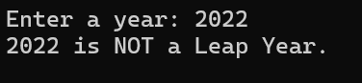

**Task 8:**

#include <stdio.h>

int main() {

int num;

printf("Enter a Number: ");

scanf("%d", &num);

if (num>0){

printf("%d is Positive",num);

}

else if (num<0) {

printf("%d is Negative", num);

}

else{

printf("%d is zero", num);

}

return 0;

}

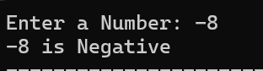

**Task 9:**

#include <stdio.h>

int main() {

int num;

printf("Enter a number (1-7): ");

scanf("%d", &num);

switch(num) {

case 1:

printf("Monday\n");

break;

case 2:

printf("Tuesday\n");

break;

case 3:

printf("Wednesday\n");

break;

case 4:

printf("Thursday\n");

break;

case 5:

printf("Friday\n");

break;

case 6:

printf("Saturday\n");

break;

case 7:

printf("Sunday\n");

break;

default:

printf("Invalid input! Please enter a number between 1 and 7.\n");

}

return 0;

}

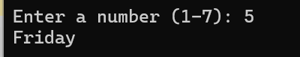

**Task 10:**

#include <stdio.h>

int main() {

int password;

int predefined = 1234; // You can change this to any value you like

printf("Enter the password: ");

scanf("%d", &password);

if (password == predefined) {

printf("Access Granted\n");

} else {

printf("Access Denied\n");

}

return 0;

}

